**Spring REST using Spring Boot 3**

**Hands on 1**

**Create a Spring Web Project using Maven**

**Project Structure :**

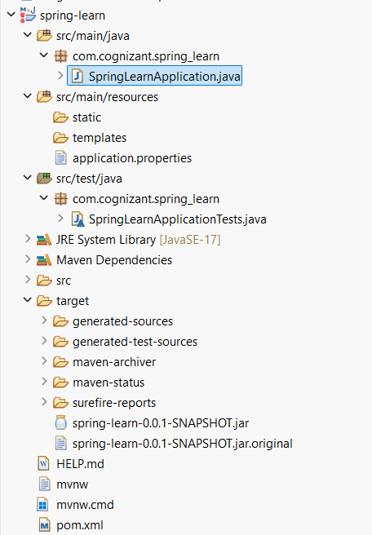

**Code:**

SpringLearnApplication.java:

package com.cognizant.spring_learn;

import org.slf4j.Logger;

import org.slf4j.LoggerFactory;

import org.springframework.boot.SpringApplication;

import org.springframework.boot.autoconfigure.SpringBootApplication;

@SpringBootApplication

public class SpringLearnApplication {

private static final Logger *LOGGER* = LoggerFactory.*getLogger*(SpringLearnApplication.class);

public static void main(String[] args) {

SpringApplication.*run*(SpringLearnApplication.class, args);

*LOGGER*.info("STARTING SPRINGLEARN APPLICATION");

}

}

**Output :**

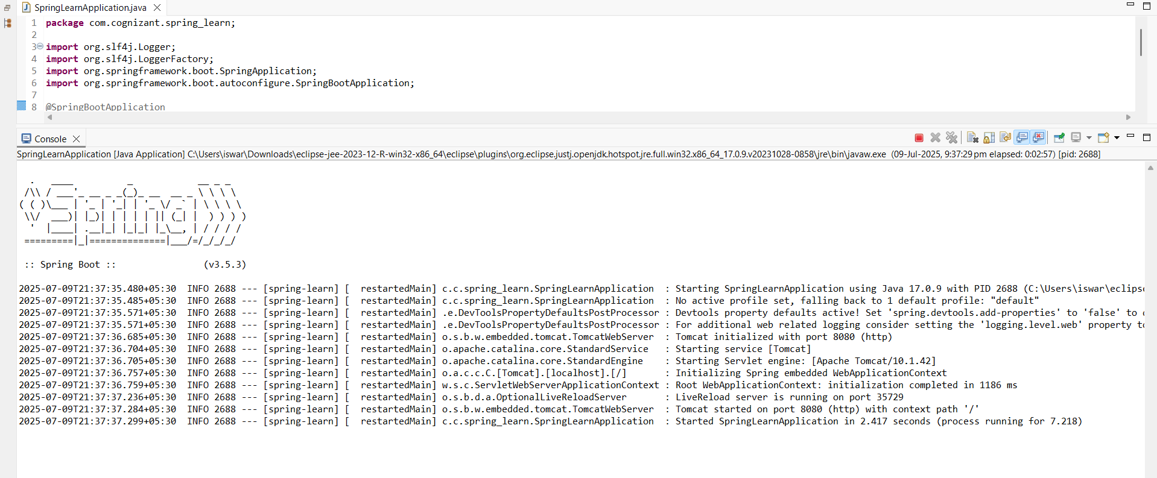

**Hands on 4**

**Spring Core – Load Country from Spring Configuration XML**

**Project Structure :**

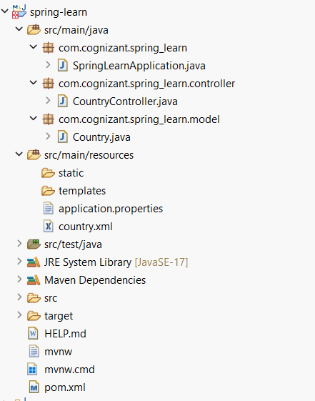

**Code :**

SpringLearnApplication.java :

**package** com.cognizant.spring_learn;

**import** com.cognizant.spring_learn.model.Country;

**import** org.slf4j.Logger;

**import** org.slf4j.LoggerFactory;

**import** org.springframework.boot.SpringApplication;

**import** org.springframework.boot.autoconfigure.SpringBootApplication;

**import** org.springframework.context.ApplicationContext;

**import** org.springframework.context.support.ClassPathXmlApplicationContext;

**import** java.util.List;

@SpringBootApplication

**public** **class** SpringLearnApplication {

**private** **static** **final** Logger ***LOGGER*** = LoggerFactory.*getLogger*(SpringLearnApplication.**class**);

**public** **static** **void** main(String[] args) {

SpringApplication.*run*(SpringLearnApplication.**class**, args);

*displayCountry*(); // Task 2

*displayCountries*(); // 👉 Task 4 (new)

}

/** Task 2 – single bean **/

**public** **static** **void** displayCountry() {

ApplicationContext context = **new** ClassPathXmlApplicationContext("country.xml");

Country country = context.getBean("country", Country.**class**);

***LOGGER***.debug("Country (single): {}", country);

}

/** Task 4 – list of beans **/

**public** **static** **void** displayCountries() {

ApplicationContext context = **new** ClassPathXmlApplicationContext("country.xml");

@SuppressWarnings("unchecked")

List<Country> countryList = (List<Country>) context.getBean("countryList");

**for** (Country c : countryList) {

***LOGGER***.debug("Country (list): {}", c);

}

}

}

CountryController.java :

**package** com.cognizant.spring_learn.controller;

**import** com.cognizant.spring_learn.model.Country;

**import** org.springframework.context.ApplicationContext;

**import** org.springframework.context.support.ClassPathXmlApplicationContext;

**import** org.springframework.web.bind.annotation.GetMapping;

**import** org.springframework.web.bind.annotation.RestController;

@RestController

**public** **class** CountryController {

@GetMapping("/country")

**public** Country getCountry() {

ApplicationContext context = **new** ClassPathXmlApplicationContext("country.xml");

**return** context.getBean("country", Country.**class**);

}

}

Country.java :

**package** com.cognizant.spring_learn.model;

**public** **class** Country {

**private** String code;

**private** String name;

**public** Country() {} // default ctor

**public** String getCode() { **return** code; }

**public** **void** setCode(String code) { **this**.code = code; }

**public** String getName() { **return** name; }

**public** **void** setName(String name) { **this**.name = name; }

@Override

**public** String toString() {

**return** "Country [code=" + code + ", name=" + name + "]";

}

}

Country.xml :

<?xml version=*"1.0"* encoding=*"UTF-8"*?>

<beans xmlns=*"http://www.springframework.org/schema/beans"*

xmlns:xsi=*"http://www.w3.org/2001/XMLSchema-instance"*

xsi:schemaLocation=*"*

*http://www.springframework.org/schema/beans*

*http://www.springframework.org/schema/beans/spring-beans.xsd"*>

<!-- single bean (used in Tasks 2 & 3) -->

<bean id=*"country"* class=*"com.cognizant.spring_learn.model.Country"*>

<property name=*"code"* value=*"IN"*/>

<property name=*"name"* value=*"India"*/>

</bean>

<!-- list of Country beans (for Task 4) -->

<bean id=*"countryList"* class=*"java.util.ArrayList"*>

<constructor-arg>

<list>

<bean class=*"com.cognizant.spring_learn.model.Country"*>

<property name=*"code"* value=*"IN"*/>

<property name=*"name"* value=*"India"*/>

</bean>

<bean class=*"com.cognizant.spring_learn.model.Country"*>

<property name=*"code"* value=*"US"*/>

<property name=*"name"* value=*"United States"*/>

</bean>

<bean class=*"com.cognizant.spring_learn.model.Country"*>

<property name=*"code"* value=*"JP"*/>

<property name=*"name"* value=*"Japan"*/>

</bean>

</list>

</constructor-arg>

</bean>

</beans>

**Output :**

